SIMATS ENGINEERING
ASSESSMENT TOOL 1

COURSE NAME: OBJECT ORIENTED ANALYSIS AND DESIGN
COURSE CODE: CSA1102

COURSE OUTCOME COVERED

CO2: Design UML diagrams to represent system requirements and architecture. (BL3)

Assessment Tool Weightage: 40%

QUESTIONS: Any 4 Total Marks:40

Annexure A

ANALYTICAL PROBLEM SOLVING

Code of Conduct:

I N.Nesarajan /192511386(Name / Reg No) certify that this submission is my original work and that I have adhered to the guidelines specified for this assessment.
I understand that any violation of academic integrity rules will result in disciplinary action.

Signature of the student:

Annexure A

ANALYTICAL PROBLEM SOLVING

1. Use Case Diagram Problem
A Hospital Management System allows patients to book appointments, doctors to update medical records, and administrators to manage hospital resources. The requirements are not clearly documented.
Tasks:
a) Identify all actors involved in the system.
b) List the primary use cases.
c) Define relationships (include, extend, generalization).
d) Construct a complete Use Case Diagram representing system functionality.
(10 Marks)

2. Class Diagram Problem
A Library Management System contains entities such as Book, Member, Librarian, and IssueRecord. The relationships among entities are not properly defined.
Tasks:
a) Identify classes with attributes and methods.
b) Define relationships (association, aggregation, inheritance).
c) Specify multiplicity between classes.
d) Design a detailed Class Diagram for the system.
(10 Marks)

3. Sequence Diagram Problem
In an Online Food Ordering System, a customer selects food items, places an order, makes payment, and receives order confirmation. The interaction flow is unclear.
Tasks:
a) Identify objects involved in the process.
b) Define message flow between objects.
c) Represent activation and lifelines.
d) Construct a Sequence Diagram showing complete interaction flow.
(10 Marks)

4. Activity Diagram Problem
A Student Admission System includes application submission, document verification, fee payment, and enrollment confirmation. The workflow lacks proper decision-making steps.
Tasks:
a) Identify all activities in the workflow.
b) Add decision nodes for approval/rejection.
c) Include parallel processing where applicable.
d) Design an optimized Activity Diagram.
(10 Marks)

5. State Diagram Problem
A Vending Machine System operates through states such as Idle, Product Selected, Payment Received, Product Dispensed, and Transaction Completed.
Tasks:
a) Identify all possible states.
b) Define events triggering transitions.
c) Include initial and final states.
d) Construct a State Transition Diagram representing system behavior.
(10 Marks)

6. Component Diagram Problem
An Online Learning Platform consists of modules such as User Management, Course Management, Assessment Module, Content Delivery Module, and Notification Service.
Tasks:
a) Identify major system components.
b) Define interfaces between components.
c) Show dependencies among modules.
d) Construct a Component Diagram representing system architecture.
(10 Marks)

7. Deployment Diagram Problem
A Smart Traffic Monitoring System uses roadside sensors to collect vehicle data. The data is transmitted to a central cloud server where traffic authorities monitor congestion through a web dashboard. Alerts are generated during traffic violations and accidents.
Tasks:
a) Identify all hardware nodes involved in the system.
b) Specify software components deployed on each node.
c) Define communication links between nodes.
d) Construct a complete Deployment Diagram representing the system architecture.
(10 Marks)
RUBRICS FOR CALCULATION

ANALYTICAL PROBLEM SOLVING

Criteria | Weightage | Level 4 (Exemplary) | Level 3 (Proficient) | Level 2 (Developing) | Level 1 (Beginning)
Problem Understanding | 20% | Clearly interprets problem, identifies all parameters and requirements accurately | Understands problem with minor gaps | Partial understanding; misses key elements | Misinterprets or unable to understand problem
Method Selection | 20% | Selects most appropriate method/formula with strong justification | Selects correct method with minor errors | Inappropriate or partially correct method | Unable to select method
Solution Process | 25% | Logical, systematic steps with correct approach throughout | Mostly correct steps with minor mistakes | Disorganized steps; multiple errors | No clear process
Accuracy of Calculation | 20% | All calculations accurate; correct final answer | Minor calculation errors | Frequent errors; incorrect final answer | No valid calculations
Interpretation of Results | 15% | Clearly interprets results with units and engineering relevance | Basic interpretation with minor omissions | Limited or unclear interpretation | No interpretation

ANSWERS

QUESTION NO. 2 – Class Diagram Problem

Problem Understanding
The Library Management System contains four main entities: Book, Member, Librarian, and IssueRecord. The relationships between these entities must be identified along with their attributes, methods, associations, inheritance (if applicable), and multiplicity. The goal is to design a complete UML Class Diagram representing the system.

Solution
(a) Identify classes with attributes and methods
Class 1: Book
Attributes
- bookID : int
- title : String
- author : String
- publisher : String
- isbn : String
- availability : Boolean
Methods
- issueBook()
- returnBook()
- searchBook()
- displayBookDetails()

Class 2: Member
Attributes
- memberID : int
- name : String
- phone : String
- email : String
- address : String
Methods
- borrowBook()
- returnBook()
- reserveBook()
- viewBorrowedBooks()

Class 3: Librarian
Attributes
- librarianID : int
- name : String
- employeeID : String
Methods
- addBook()
- removeBook()
- updateBook()
- issueBook()
- collectBook()

Class 4: IssueRecord
Attributes
- issueID : int
- issueDate : Date
- dueDate : Date
- returnDate : Date
- fineAmount : double
Methods
- calculateFine()
- updateReturnDate()
- generateIssueRecord()

(b) Define Relationships
Association
- Member borrows Book.
- Librarian manages Book.
- IssueRecord stores borrowing details.
Aggregation
- Library contains many Books.
- Library contains Members.
Inheritance
No inheritance is required because all four classes represent different real-world entities.

(c) Multiplicity

Relationship | Multiplicity
Member → IssueRecord | 1 : 0..*
Book → IssueRecord | 1 : 0..*
Librarian → IssueRecord | 1 : 0..*
IssueRecord → Book | 1
IssueRecord → Member | 1

(d) UML Class Diagram
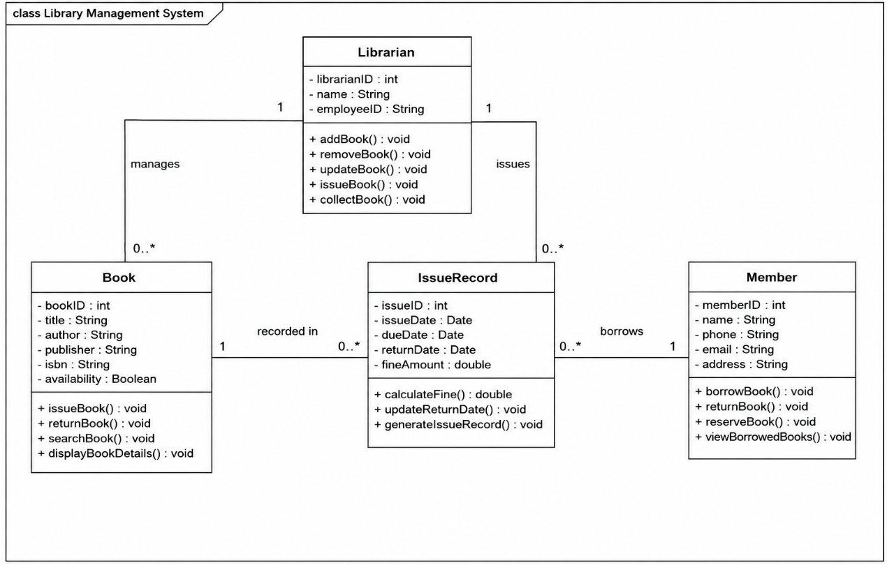

Explanation
- Book stores information about every book available in the library.
- Member represents registered users who can borrow books.
- Librarian manages library operations such as adding, updating, issuing, and collecting books.
- IssueRecord maintains transaction details including issue date, return date, due date, and fine amount.
- The associations show how books are issued to members under the supervision of a librarian.

Conclusion
The UML Class Diagram provides a clear representation of the Library Management System by defining classes, attributes, methods, relationships, and multiplicities. It helps developers understand the system structure and simplifies implementation and maintenance.

QUESTION NO. 3 – Sequence Diagram Problem

Problem Understanding
An Online Food Ordering System allows customers to browse food items, place orders, make online payments, and receive order confirmation. The sequence of interactions between the customer and system components is not clearly defined. A UML Sequence Diagram is required to represent the complete interaction flow between the objects involved in the ordering process.

Solution
(a) Identify objects involved in the process
The main objects involved are:
- Customer
- Food Ordering System
- Restaurant
- Payment Gateway
- Order Database
- Notification Service

(b) Define message flow between objects
The sequence of messages is as follows:
- Customer selects food items.
- Food Ordering System displays the selected items.
- Customer places the order.
- Food Ordering System sends the order to the Restaurant.
- Restaurant confirms item availability.
- Food Ordering System requests payment.
- Customer makes payment through the Payment Gateway.
- Payment Gateway verifies the payment.
- Payment status is returned to the Food Ordering System.
- Order details are stored in the Order Database.
- Notification Service sends order confirmation to the customer.
- Customer receives the confirmation message.

(c) Represent activation and lifelines
Lifelines
- Customer
- Food Ordering System
- Restaurant
- Payment Gateway
- Order Database
- Notification Service
Activation
- Customer activates the Food Ordering System by selecting food.
- Food Ordering System becomes active while processing the order.
- Restaurant is activated to verify the order.
- Payment Gateway is activated during payment processing.
- Order Database is activated while storing order details.
- Notification Service is activated when sending the confirmation message.

(d) Sequence Diagram

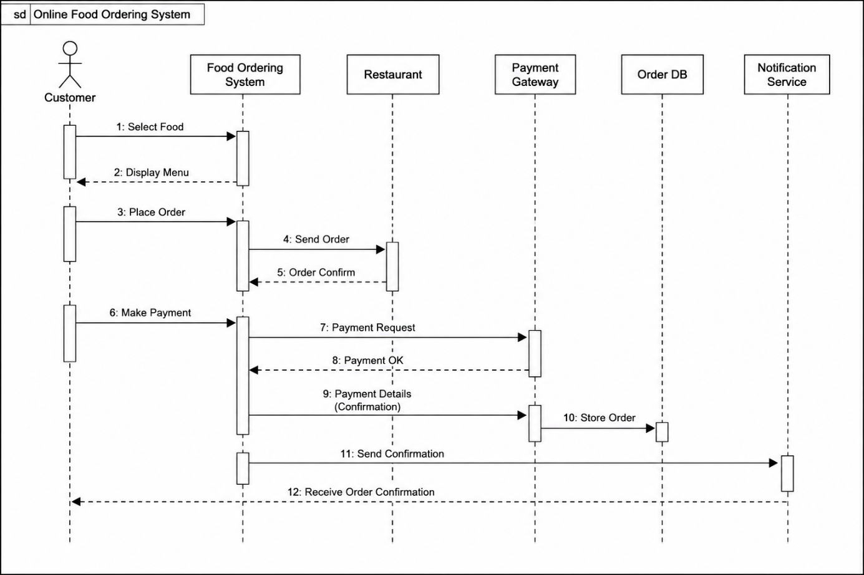

Explanation
- The Customer begins the process by selecting food items and placing an order.
- The Food Ordering System receives the order and forwards it to the Restaurant.
- The Restaurant checks the availability of food items and confirms the order.
- The Customer completes the payment through the Payment Gateway.
- Once payment is successful, the Food Ordering System stores the order details in the Order Database.
- Finally, the Notification Service sends an order confirmation to the customer.
The sequence diagram clearly illustrates the chronological order of interactions among all system components.

Conclusion
The UML Sequence Diagram models the dynamic behavior of the Online Food Ordering System by showing the interaction between the customer, ordering system, restaurant, payment gateway, database, and notification service. It helps developers understand the communication flow and ensures that every step—from food selection to order confirmation—is executed in the correct sequence.
QUESTION NO. 4 – Activity Diagram Problem

Problem Understanding
A Student Admission System manages the admission process from application submission to enrollment. The workflow includes application submission, document verification, fee payment, and enrollment confirmation. Decision-making and parallel processing are required to make the admission process efficient. An Activity Diagram is used to represent the complete workflow.

Solution
(a) Identify all activities in the workflow
The main activities involved are:
- Start
- Fill Admission Application
- Submit Application
- Verify Documents
- Check Eligibility
- Approve or Reject Application
- Pay Admission Fee
- Generate Student ID
- Create Student Record
- Confirm Enrollment
- End

(b) Add decision nodes for approval/rejection
The following decision points are included:
- Documents Verified?
  - Yes → Continue to Eligibility Check
  - No → Reject Application
- Eligible for Admission?
  - Yes → Proceed to Fee Payment
  - No → Reject Application
- Fee Paid Successfully?
  - Yes → Continue Enrollment
  - No → Wait for Payment / Cancel Admission

(c) Include parallel processing where applicable
After successful fee payment, two activities can occur simultaneously:
- Generate Student ID
- Create Student Record
Both activities are completed before enrollment confirmation.

(d) Activity Diagram
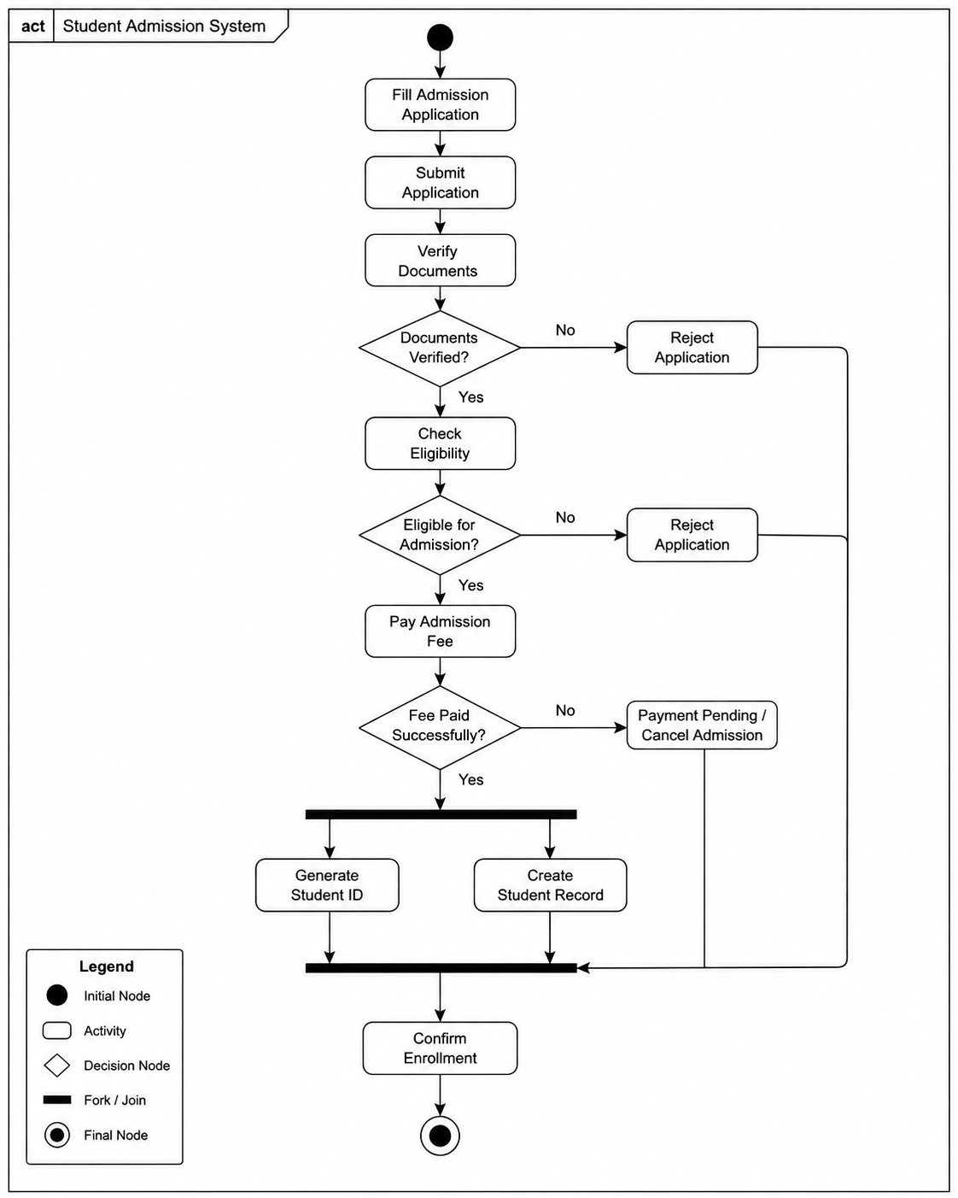

Explanation
- The admission process starts when the student fills and submits the application.
- The submitted documents are verified by the admission office.
- If the documents are invalid, the application is rejected.
- Eligible students proceed to fee payment.
- After successful payment, the system performs two activities simultaneously:
  - Generates the Student ID.
  - Creates the Student Record.
- After both activities are completed, enrollment is confirmed, and the admission process ends.
The Activity Diagram clearly shows the sequence of activities, decision points, and parallel processing in the admission workflow.

Conclusion
The UML Activity Diagram provides a clear representation of the Student Admission System by illustrating the flow of activities, decision nodes, parallel processing, and final enrollment. It improves understanding of the admission process and helps developers design an efficient workflow.

QUESTION NO. 5 – State Diagram Problem

Problem Understanding
A Vending Machine System changes its behavior based on user actions. The machine starts in the Idle state, allows the user to select a product, accepts payment, dispenses the selected product, and completes the transaction before returning to the Idle state. A UML State Diagram is used to represent the different states and the events that trigger transitions between them.

Solution
(a) Identify all possible states
The Vending Machine consists of the following states:
- Initial State
- Idle
- Product Selected
- Payment Received
- Product Dispensed
- Transaction Completed
- Final State

(b) Define events triggering transitions
Current State | Event | Next State
Initial State | Machine Powered ON | Idle
Idle | Customer Selects Product | Product Selected
Product Selected | Customer Makes Payment | Payment Received
Payment Received | Payment Successful | Product Dispensed
Product Dispensed | Product Delivered | Transaction Completed
Transaction Completed | Reset Machine | Idle
Payment Received | Payment Failed | Idle
Product Selected | Cancel Selection | Idle

(c) Include initial and final states
- Initial State (●) represents the vending machine being powered on.
- Final State (◎) represents the end of the transaction cycle.

(d) State Transition Diagram
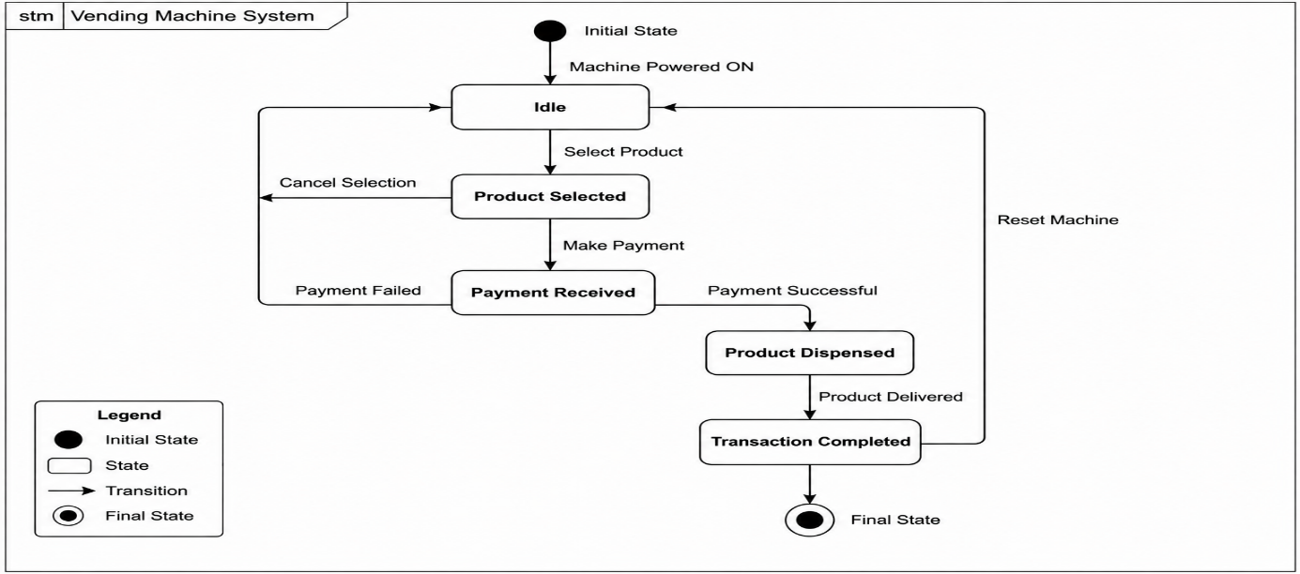

Explanation
- The vending machine starts in the Idle state after being powered on.
- The customer selects a product, changing the state to Product Selected.
- The customer then makes the payment.
- If the payment is successful, the machine enters the Product Dispensed state and delivers the selected product.
- After dispensing the product, the machine completes the transaction and returns to the Idle state for the next customer.
- If the customer cancels the selection or the payment fails, the machine directly returns to the Idle state.
The State Diagram clearly illustrates how the vending machine changes its state in response to different user actions and system events.

Conclusion
The UML State Diagram models the behavior of the Vending Machine System by showing all possible states, transition events, initial and final states, and alternate paths such as payment failure or order cancellation. It helps developers understand the system's dynamic behavior and ensures smooth transaction processing.

